**Project Scope for Streamflow and Balanced Unit Hydrograph Processing**

**Overview:**

The project aims to develop a graphical user interface (GUI) that integrates various functionalities for downloading and processing streamflow data, detecting peaks, and creating normalized hydrographs. The GUI will streamline the execution of multiple functions, including USGS data retrieval, discharge peak detection, hydrograph plotting, Gaussian smoothing, and the creation of Dimensionless Unit Hydrographs (DUH). Users will be able to input site information, customize parameters, and visualize results through an intuitive interface.

The Python script that implements these functionalities is already available, and a Streamlit web application (see the photo below) has been developed to provide a user-friendly interface for executing the script.

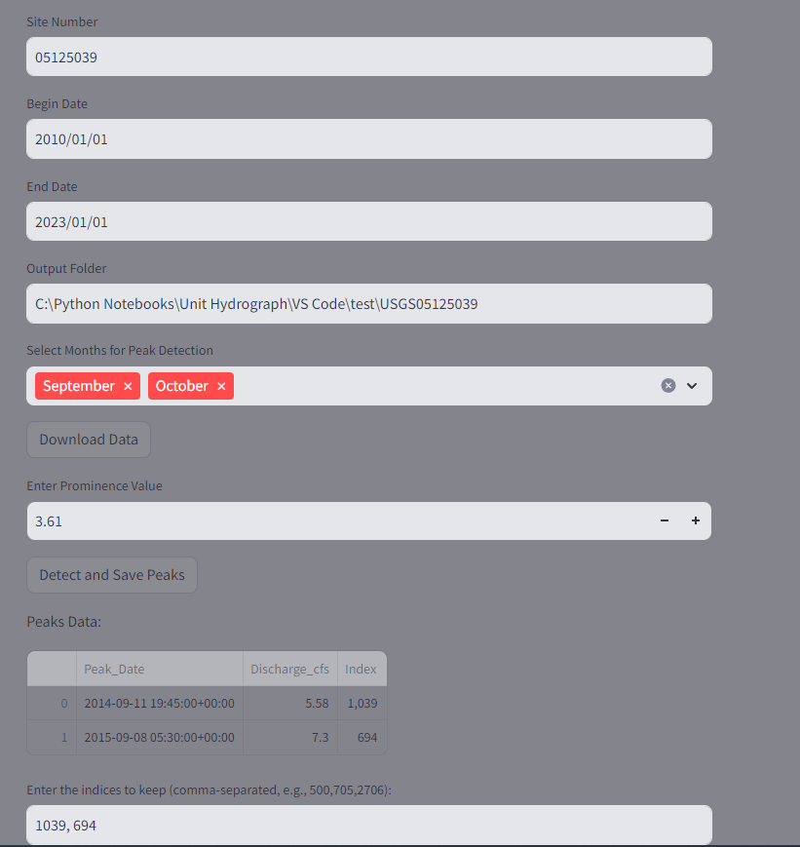

**Phases:**

**Phase 1: GUI Development and Function Integration**

* + Develop a basic interface that allows users to input the USGS site number, date ranges, and output directories.
  + Implement functionality to download and process streamflow data, detect discharge peaks, and update peak data.
  + Integrate hydrograph plotting and Gaussian smoothing features, allowing users to interact with and analyze discharge data.
  + Provide options for users to customize parameters such as peak prominence, Gaussian smoothing sigma values, and window sizes for hydrograph extraction.
  + Include error handling for missing or incorrect input data, with clear user feedback via the GUI.

**Phase 2: Testing and Finalization by AECOM SMEs**

* + Conduct extensive testing to validate that the GUI handles multiple sites, date ranges, and large datasets efficiently. Perform debugging to ensure all features work seamlessly in sequence, and provide visual feedback during processing steps.
  + Finalize the GUI layout for clarity and ease of use, ensuring that users can intuitively navigate through the different processes.
  + Provide feedback for modifications.

**Requirements:**

* **Required**:
  + The GUI must support easy input of USGS site information, date ranges, and output directories.
  + It should guide users through a step-by-step process, starting from data download to DUH generation, with progress tracking and clear instructions at each stage.
  + Progress bars and logs must be displayed to track the execution of each function (e.g., downloading data, detecting peaks, applying smoothing).
  + The system must handle various input parameters, such as prominence value, smoothing sigma values, and window sizes for peak event hydrograph extraction.
  + The code must be interactive, allowing users to engage with graphs, make adjustments, and have the code dynamically update and proceed based on those adjustments (please see the developed web app for details).

**Dependencies:**

* **Python 3.x (Tested on Python 3.9)**
  + Libraries: streamlit, pandas, matplotlib, plotly, hydrofunctions, scipy, numpy, os, glob.

**GUI Layout Description:**

* **Main Window**:
  + **File Selection and Parameter Input**:
    - Fields for entering USGS site number, date ranges (start and end dates), and output directory.
    - Dropdowns and input fields for selecting peak detection months, prominence value, Gaussian smoothing sigma, and event hydrograph window sizes.
  + **Execution Buttons**:
    - Buttons to initiate data download, detect peaks, apply Gaussian smoothing, and generate hydrographs.
    - Button for saving processed data and results in CSV format.
  + **Progress Bar and Logs**:
    - Real-time display of progress for each task, along with a logging window to show status and errors during execution.

**Estimated Hours:**

* **Estimate**: AECOM SMEs require 40-50 hours of testing the GUI to ensure that all scripts run correctly in sequence, including error handling, large dataset management, and performance optimization.
* **Estimate:** Zeus Hydrology team will need hours to attend and prepare for the progress meetings and technical discussions.

This scope provides a comprehensive plan for developing a GUI that simplifies the workflow of streamflow data processing, peak detection, and hydrograph generation, ensuring an efficient and user-friendly interface.

**Input Data List for Streamflow and Hydrograph Processing GUI**

1. **USGS Site Number**
   * **Type**: String (Text Input)
   * **Description**: The USGS site number from which streamflow data will be retrieved.
2. **Start Date**
   * **Type**: Date (Date Picker)
   * **Description**: The start date for downloading streamflow data.
3. **End Date**
   * **Type**: Date (Date Picker)
   * **Description**: The end date for downloading streamflow data.
4. **Output Directory**
   * **Type**: Directory (Folder Path)
   * **Description**: The folder where output files (e.g., processed data, graphs, CSV files) will be saved.
5. **Selected Months for Peak Detection**
   * **Type**: List of Strings (Multiselect Dropdown)
   * **Description**: A selection of months for filtering streamflow data for peak detection (e.g., "January", "September").
6. **Prominence Value**
   * **Type**: Float (Number Input)
   * **Description**: A numerical value representing the prominence of peaks used in peak detection.
7. **Gaussian Smoothing Sigma**
   * **Type**: Float (Slider)
   * **Description**: The sigma value for applying Gaussian smoothing to discharge data.
8. **Window Size Before Peak**
   * **Type**: Integer (Slider)
   * **Description**: The number of data points to include before a peak in the hydrograph window.
9. **Window Size After Peak**
   * **Type**: Integer (Slider)
   * **Description**: The number of data points to include after a peak in the hydrograph window.
10. **CSV File Path for Peaks Data**
    * **Type**: File (File Path)
    * **Description**: The path to the CSV file containing peak discharge information.
11. **CSV File Path for Discharge Data**
    * **Type**: File (File Path)
    * **Description**: The path to the CSV file containing the streamflow/discharge data for the site.
12. **Sigma for Gaussian Smoothing**
    * **Type**: Float (Slider)
    * **Description**: A value determining the intensity of the smoothing applied to hydrograph data.
13. **Event Hydrograph File Path**
    * **Type**: File (File Path)
    * **Description**: The path to the CSV file containing the hydrograph data for a specific event.
14. **Dimensionless Unit Hydrograph (DUH) Directory**
    * **Type**: Directory (Folder Path)
    * **Description**: The folder containing files for dimensionless unit hydrograph (DUH) generation.
15. **Interpolation Method for DUH**
    * **Type**: String (Dropdown Selection)
    * **Description**: The interpolation method to be applied when processing DUH (e.g., "linear", "quadratic", "akima").